Converters
: We have 2 ideas to fix this Electrical issus
.Using 2 DC-DC converters and 1 Buck Converter
.Using power supply 12V and 1 Buck Converter
: First idea Using The 2 DC converters
DC to DC Converter (Step Down from 48V to 12V 30A) Waterproof 360W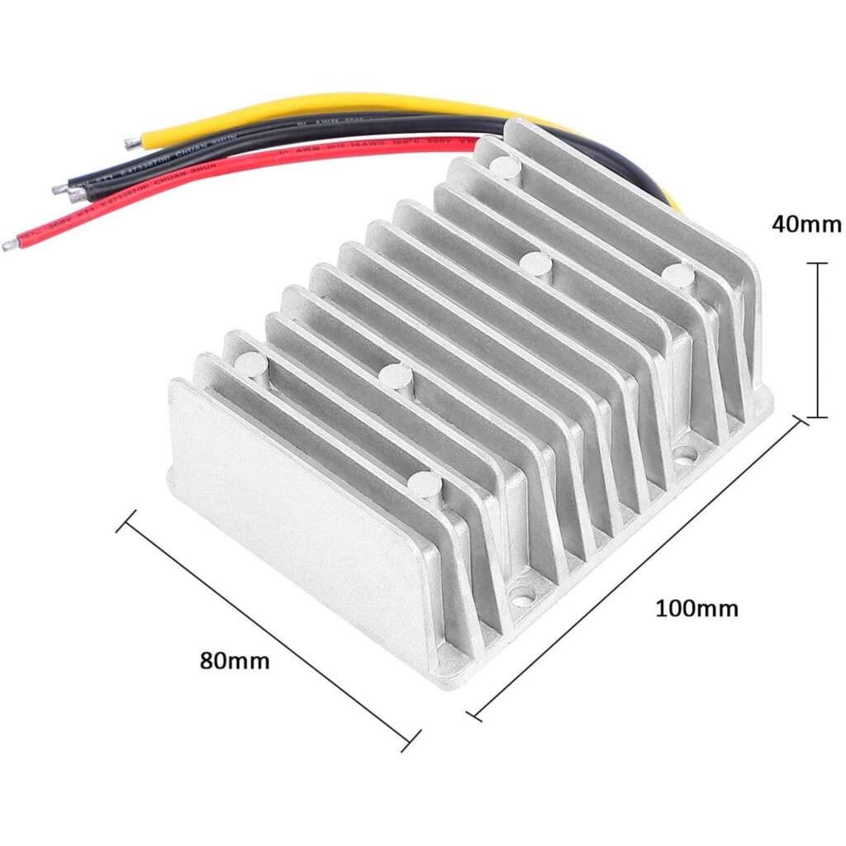
We’re using two DC-DC converters to step down from 48V to 12V because we’ve got a lot of components that need high current , like the thrusters, cameras, and the micro ROV. If we used just one converter, it would be under too much load and might overheat or fail.
By using two in parallel, the current gets shared between them, so each one handles less stress. Plus, if one of them stops working for any reason, the other one can keep things running ,which is super important underwater where we can’t just go and fix things easily.
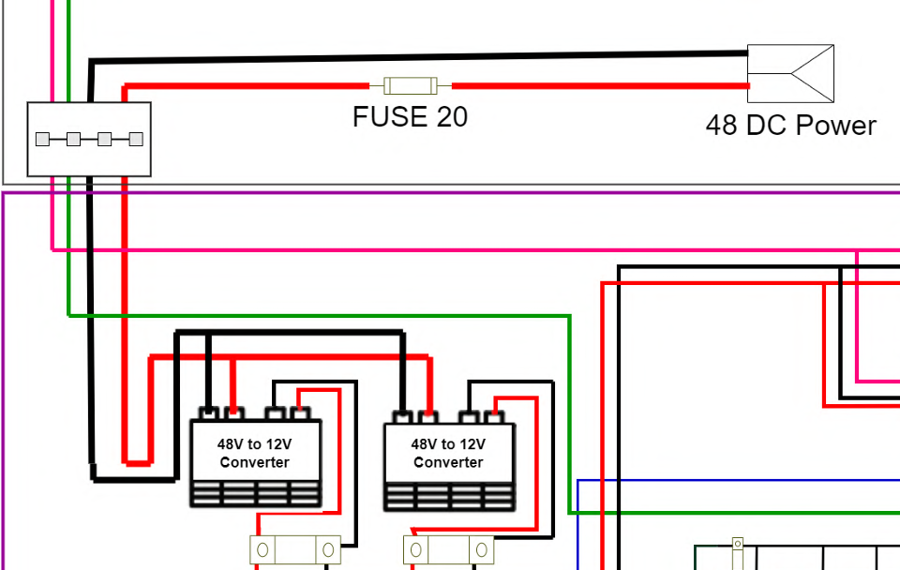
After the DC converters step the voltage down to 12V, we use a buck converter to drop it further to 5V. That’s because some of our components , like the Arduino and the sensors , only work with 5V, and giving them 12V would damage them.
The buck converter makes sure they get a stable 5V supply, and since it’s efficient, it doesn’t waste a lot of power or generate too much heat. It’s a small but essential part of the power system.
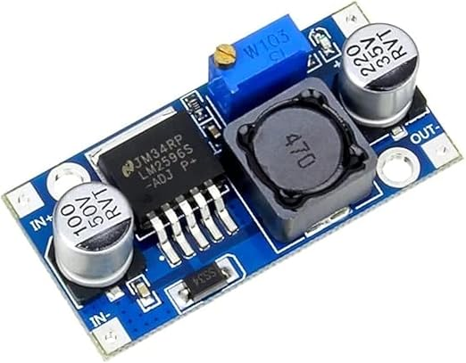
:The prices of each component
DC-DC Converter ( 2900 – 3300 ) LE (available in egypt)
Buck Converter (90) LE (available in egypt)

Second Idea using (1 power supply 1 buck Converter):
System Over View
This ROV system uses a 220V AC to 12V DC Power Supply to provide electrical energy for the entire system. High-consumption components such as motors can run directly from the 12V supply, while low-voltage components like sensors and controllers require further voltage regulation via Buck Converters
Power Supply Specifications:
Input Voltage: 220V AC (from wall socket).
Output Voltage: 12V DC.
Current Rating: Depends on your system (e.g., 10A, 20A,30A, etc.).
Purpose: Provides stable DC power for
- Motors
- Thrusters
- Lighting systems
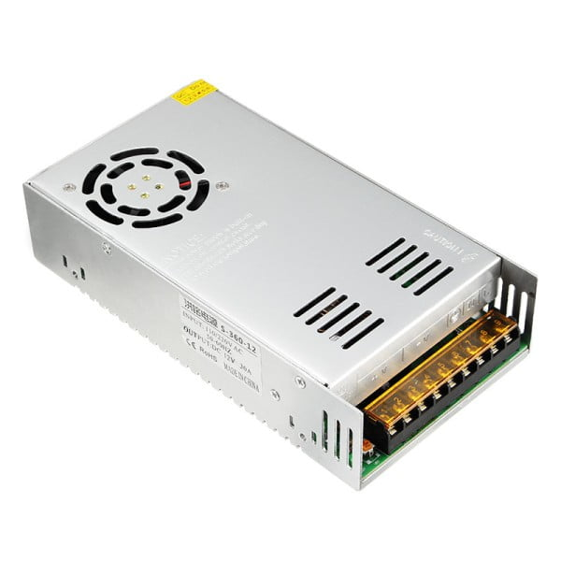
Buck Converter Use:
Since some electronic components (controllers, sensors) need less than 12V (5V or 3.3V) a Buck Converter is used after the power supply.
- Input Voltage: 12V DC.
- Output Voltage: 5V / 3.3V.
- Used For:
  - Arduino or ESP8266/NodeMCU or Rasbery pi
  - IMU sensors, temperature/pressure sensors
  - Communication modules
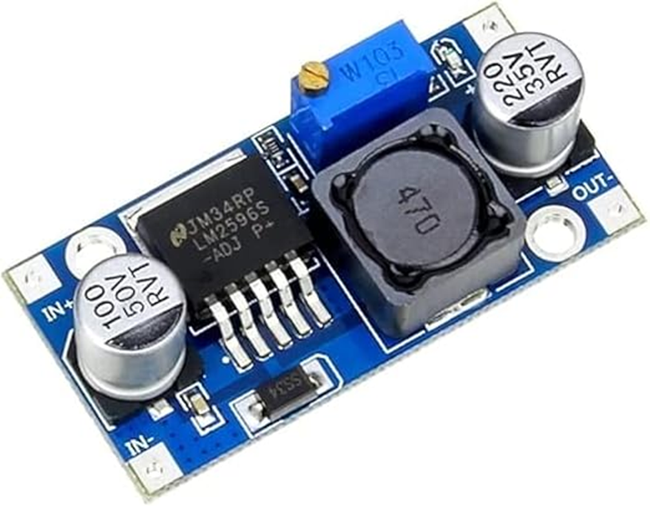
The prices of each component:
Power Supply ( 500 – 1500 ) LE (available in egypt)
Buck Converter (90) LE (available in egypt)

